Present Perfect or Past Simple?

Marleneanu Cerasela Iuliana, Liceul Tehnologic Iorgu Vârnav Liteanu,
Liteni, Suceava

- I have done or I did?
We won the Cup 50 years ago.  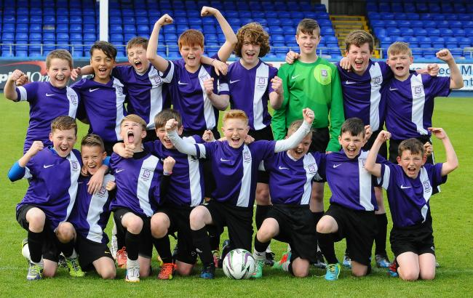  We’ve won the Cup! It’s ours! | 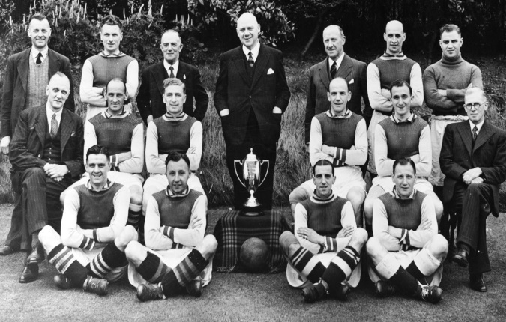
The Present Perfect tells us about the past and the present. The boys have won the Cup, so it’s theirs now. | The past simple tells us about the past, a time which is finished. 50 years ago is in the past.

We use the past Simple ( not the Present Perfect ) to talk about times in the past such as yesterday, last week, in 1994, a hundred years ago.
Present Perfect | Past Simple
Ann has packed her case. (So her things are in the case now.)  The plane has just landed.  I’ve turned the TV on. (It’s on now.) | Ann packed her case last night. (Her things may be unpacked now.)  The plane landed ten minutes ago.  I turned the TV on earlier, but it’s off again now.

Practice
Put in the correct verb form.
I’ve done ……….. (I/ do) the entire housework. The flat is really clean now.

A young couple bought…….. (buy) the house next door. But they didn’t live there long.

- Our visitors ……………………. (arrive). They’re sitting in the garden.
- There is still a problem with the television. Someone……………………( repair) it, but then it broke down again.
- …………………………………( I/ lose) my bank card. I can’t find it anywhere.
- The match……………………..( start). United are playing well.
- My sister ………………( run) away from home. But she came back two days later.
- Daniel………………….( earn) some money last week. But I ‘m afraid he’s already spent it all.
- …………………………………( we/ plant) an apple tree in the garden. Unfortunately it died.
- Prices……………..( go) up. Everything is more expensive this year.
- Someone …………………( turn) on the hi-fi. What’s that song called?
- ……………………..( I/ phone) the office at eleven to speak to the manager, but he isn’t there today.
- …………………………….( I/ make) a cake. Would you like a piece?
- The runner Amos Temila ……………….( break) the world record for 1500 meters in Frankfurt. Then two days later in Helsinki, Lee Williams ran it in an even faster time.

- I’ve done it. I did it yesterday.

Trevor: We’ve bought a new car.
Tom: Oh, have you? What sort?
Laura: An Adagio. We bought it last week.
We often give a piece of news in the Present Perfect, e.g. We’ve bought a new car. ( The car is ours now.) We use the Past Simple, e.g. We bought it last week, to give details or to ask for details about things such as when and where it happened.

Here are some more examples.
I’ve found my wallet.- Oh, good. Where did you find it?
Your parcel has arrived. The postman brought it at eight o’clock.
They’ve closed the factory.- Really ? When did they do that?

Practice
Things that have happened today are on the radio and TV news. Give the news using the Present Perfect and Past Simple.
the Prime Minister/ visit Luton University/ speak to the students there/ earlier today

The Prime Minister has visited Luton University. He spoke to the students there earlier today.
- the train drivers/ go on strike/ stop work/ at twelve o’clock
………………………………………………………………………………………………………………………………….
- the Queen/ arrive in Toronto/ fly there/ in an RAF aircraft
………………………………………………………………………………………………………………………………………..
- two men/ escape from Parkhurst Prison/ get away/ during night
……………………………………………………………………………………………………………………………………………..
- the actor Howard Bates/ die in a car accident/ his car/ crash into a wall
………………………………………………………………………………………………………………………………………………
- Linda Jones/ win the women’s marathon/ run it / in 2 hours 27 minutes
……………………………………………………………………………………………………………………………………………

