TEST PAPER -5th GRADE-FOR STUDENTS WITH SPECIAL NEEDS
PĂȘTIN DIANA ELENA
LICEUL CU PROGRAM SPORTIV “MIRCEA ELIADE”, BUCUREȘTI

- Write the following numbers with cypher (Scrieți următoarele numere cu cifre) :
three-
ten-
four-
nine-
seven-
one-
six-
two-
five-
eight-
10x 1=10 points
- Complete the sentences with the correct form of the verb TO BE (AM, IS, ARE) (Completați propozițiile cu forma corectă a verbului A FI ) :
- I .............................. a student.
- He ......................... my friend.
- You ............................George.
- They.................................my parents.
- It ...........................a mouse.
5x 4=20 points
- Match the words to the colours ( Potriviți cuvintele cu culorile) :

GREEN

YELLOW

BLUE

RED

ORANGE

BROWN

WHITE

BLACK

PINK


PURPLE
10x 2=20 points
- Read and draw (Citiți și desenați ):
- There are two apples in the basket. They are red.
- There is a yellow flower in the park.
- There are four chairs in the classroom. They are green.
- There are two cats in the house. They are brown.
- There is a dog in the garden. It is black.
5x4=20 points

- Match the words to the pictures (Potriviți cuvintele cu imaginile):
Three sheep 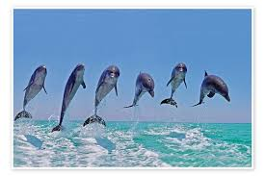
Two butterflies

Five women 
Six dolphins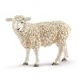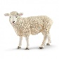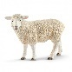

Nine apple
Seven mice
One cat 
Four dogs
Eight flowers 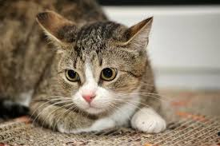
Ten books 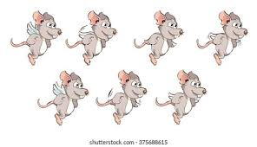

10x2= 20 points
10 points granted

